**SOIL MOISTURE MEASUREMENT**

**A COURSE-BASED PROJECT REPORT SUBMITTED**

**IN PARTIAL FULFILMENT FOR THE LAB EVALUATION OF BASIC**

**SENSORS AND TRANSDUCERS LAB**

**FOR**

**BACHELOR OF TECHNOLOGY**

**IN**

**ELECTRONICS & INSTRUMENTATION ENGINEERING**

**Submitted by**

O. SAI TEJA 21071A1049

P. HARI KRISHNA 21071A1050

P. TEJASWI 21071A1051

P. ROHITH 21071A1052

P. VENKATESH 21071A1053

**DEPARTMENT OF ELECTRONICS & INSTRUMENTATION ENGINEERING**

**VALLURUPALLI NAGESWARA RAO VIGNANA JYOTHI**

**INSTITUTE OF ENGINEERING AND TECHNOLOGY**

AICTE Approved; UGC Autonomous; JNTUH Affiliated; UGC “College with Potential for Excellence”; NAAC “A++” Grade

ISO 9001:2015 Certified; QS I.GAUGE “Diamond” Rated; NIRF 2019: 109th Rank Engineering (151–200 Band Overall)

NBA Accredited: CE, CSE, ECE, EEE, EIE, IT, ME, AE; JNTUH-Recognised Research Centres: CE, CSE, ECE, EEE, ME

**20****21-2022**

**SOIL MOISTURE MEASUREMENT**

# Introduction

1. **Theory**

Soil moisture measurement is the process of determining the amount of water present in the soil. It is a critical parameter in various fields such as agriculture, ecology, hydrology, and civil engineering, as it directly influences plant growth, soil health, water availability, and environmental processes.

There are several methods employed to measure soil moisture, each with its advantages, limitations, and applications. One common method involves using soil moisture sensors. These sensors detect the electrical conductivity or dielectric properties of the soil, which change with variations in moisture content. Contact sensors require direct insertion into the soil, while non-contact sensors can measure moisture remotely, offering convenience for large-scale monitoring.

Time-domain reflectometry (TDR) and frequency-domain reflectometry (FDR) are techniques based on measuring the propagation time or frequency of electromagnetic waves through the soil. These methods exploit the relationship between the dielectric constant of the soil and its moisture content. By analyzing the reflected waves, soil moisture content can be accurately determined.

Capacitance sensors operate on similar principles, utilizing changes in soil dielectric properties to measure moisture content. These sensors consist of electrodes buried in the soil, and the capacitance between them varies with soil moisture. This method is widely used for its simplicity, reliability, and suitability for continuous monitoring.

Gravimetric method, although labor-intensive, provides accurate measurements by comparing the mass of soil samples before and after drying. This method involves extracting soil samples, drying them in an oven, and calculating moisture content based on weight loss. While time-consuming, gravimetric measurements are often used as a reference for validating other techniques.

Remote sensing techniques, such as satellite-based and aerial imagery, offer a broader perspective by capturing spatial and temporal variations in soil moisture over large areas. These methods utilize sensors capable of detecting microwave radiation reflected or emitted from the soil surface, providing valuable data for agricultural planning, drought monitoring, and climate studies. Soil moisture measurement involves several key components, each playing a crucial role in accurately assessing the water content in the soil:

**1.Soil Moisture Sensors:** These are devices specifically designed to measure the moisture content of soil. Soil moisture sensors come in various types, including capacitance sensors, TDR (Time Domain Reflectometry) sensors, FDR (Frequency Domain Reflectometry) sensors, and resistance-based sensors. They detect changes in soil properties such as electrical conductivity or dielectric constant, which vary with moisture content.

**2.Probe or Sensor Housing**: This is the physical structure that encases the soil moisture sensor. It is designed to protect the sensor from environmental factors such as temperature fluctuations, mechanical damage, and chemical exposure. The probe is inserted into the soil either directly or remotely, depending on the type of sensor and the measurement method.

**3.Electronics and Data Logger**: Soil moisture sensors require electronic components to transmit, receive, and process signals from the soil. These electronics may include microcontrollers, amplifiers, analog-to-digital converters, and communication interfaces. A data logger is often integrated with the electronics to record and store moisture measurements over time. Data loggers may have onboard memory or connect to external storage devices or networks.

**4.Power Source**: Soil moisture sensors require power to operate the electronic components and perform measurements. The power source can be batteries, solar panels, or wired connections to external power supplies. The choice of power source depends on factors such as the sensor's location, duration of monitoring, and accessibility to electricity.

**5.Calibration Standards**: Calibration is essential to ensure the accuracy and reliability of soil moisture measurements. Calibration standards are reference materials or procedures used to establish the relationship between the sensor output and actual moisture content in the soil. Calibration may involve laboratory tests using controlled soil samples or field comparisons with gravimetric measurements.

**6.Installation and Maintenance Equipment**: Proper installation and maintenance are critical for obtaining accurate and consistent soil moisture measurements. Equipment such as augers, shovels, and hand-held probes are used to prepare the soil, insert sensors, and conduct periodic maintenance tasks such as sensor cleaning and recalibration.

**7.Data Analysis Software**: After collecting soil moisture data, analysis software is used to process, visualize, and interpret the results. This software may include statistical tools, modeling algorithms, and graphical interfaces for generating reports and making data-driven decisions.

By integrating these key components, soil moisture measurement systems can provide valuable insights into soil-water dynamics, facilitating better management of agricultural resources, environmental conservation, and engineering projects.

**B.Objective**

The primary objective of soil moisture measurement is to quantify the amount of water present in the soil at a given time and location. This information is crucial for various purposes across different fields:

**1.Agriculture**: Soil moisture measurement helps farmers optimize irrigation schedules, ensuring that crops receive the right amount of water at the right time. By monitoring soil moisture levels, farmers can prevent overwatering or underwatering, which can lead to water waste, crop stress, and reduced yields. Additionally, soil moisture data aids in determining the effectiveness of irrigation systems and scheduling planting and harvesting activities.

**2.Environmental Science**: Soil moisture measurement plays a vital role in studying and understanding ecosystems, particularly in relation to water availability and distribution. It helps researchers assess the impacts of climate change, land use practices, and disturbances such as droughts and floods on soil moisture dynamics. Monitoring soil moisture also contributes to the management and conservation of natural resources, including soil health, biodiversity, and habitat restoration.

**3.Water Resource Management**: Soil moisture data is essential for managing water resources effectively, especially in regions prone to water scarcity or drought. By monitoring soil moisture levels in watersheds, reservoir areas, and agricultural lands, water managers can make informed decisions about water allocation, conservation measures, and drought preparedness. Soil moisture measurement also supports groundwater recharge assessments and water balance modeling.

**4.Engineering and Construction**: In civil engineering and construction projects, soil moisture measurement helps engineers assess soil stability, compaction, and bearing capacity. By monitoring soil moisture levels at construction sites, engineers can mitigate risks associated with soil settlement, slope instability, and foundation failure. Soil moisture data also informs the design and maintenance of infrastructure such as roads, bridges, and buildings.

**5.Weather Forecasting and Climate Studies**: Soil moisture measurement provides valuable input for weather forecasting models and climate studies. Changes in soil moisture influence local weather patterns, including precipitation, evaporation, and temperature. By integrating soil moisture data into climate models, scientists can improve predictions of droughts, floods, and other extreme weather events, ultimately enhancing resilience to climate change.

Overall, the objective of soil moisture measurement is to support informed decision-making and sustainable management practices across various sectors, ranging from agriculture and environmental conservation to water resources, engineering, and climate resilience. By accurately quantifying soil moisture content, stakeholders can optimize resource use, mitigate risks, and enhance the resilience of ecosystems and communities to environmental challenges.

1. **Implementation**
2. **Hardware Requirements**

To implement a soil moisture measurement system, several hardware components are essential for accurate and reliable measurements. Here's a comprehensive list of each component used in such a system:

**1.Soil Moisture Sensors:**

Capacitance sensors

Time Domain Reflectometry (TDR) sensors

Frequency Domain Reflectometry (FDR) sensors

Resistance-based sensors

Probe or Sensor Housing:

Enclosure for protecting the soil moisture sensor from environmental factors

May include multiple prongs or electrodes for direct contact with the soil

**2.Data Logger:**

Micro-controller or data acquisition system for recording and storing soil moisture data

Memory storage for storing recorded data

Communication interface for transferring data to external devices

Display for real-time monitoring and configuration options

**3.Power Supply:**

Batteries (alkaline, lithium-ion, or rechargeable)

Solar panels for off-grid installations or remote locations

Wired connections to external power sources

Cables and Connectors:

Wires for connecting sensors to the data logger and power supply

Communication cables for data transfer

Power cables for supplying electricity to sensors and data logger

Connectors for secure attachment of cables to components

**4.Mounting Hardware:**

Brackets, stakes, poles, or enclosures for securely installing sensors, data logger, and other components

**5.Weather Protection:**

Weatherproof enclosures or shelters for protecting hardware components from environmental hazards

**6.Accessories:**

Extension cables for extending reach between components

Junction boxes for connecting multiple cables

Surge protectors for protecting against electrical surges or voltage fluctuations

**7.Calibration Standards:**

Reference materials or procedures used to calibrate soil moisture sensors for accuracy and reliability

**8.Maintenance Tools:**

Tools for cleaning sensors, checking connections, and performing routine maintenance tasks

**9.Documentation and Labels:**

Documentation of installation procedures, calibration parameters, and measurement protocols

Labels for identifying sensors, cables, and other components

**10.Transportation and Storage Containers:**

Containers for transporting and storing hardware components during installation and maintenance activities

1. **Diagram**

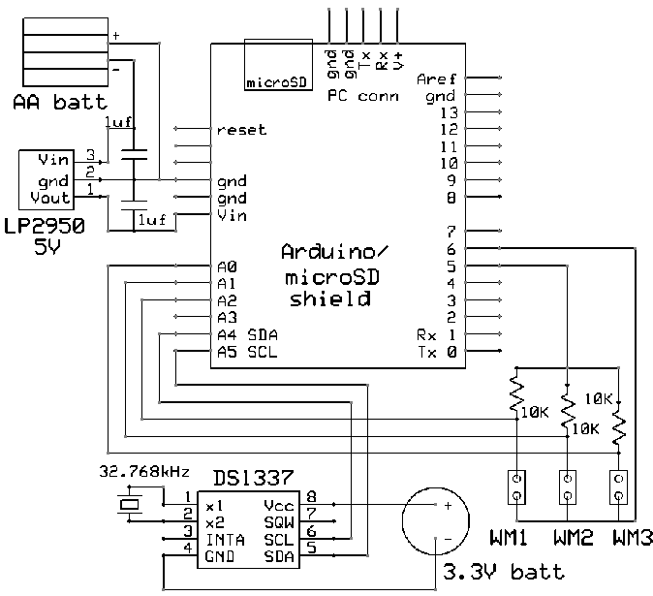

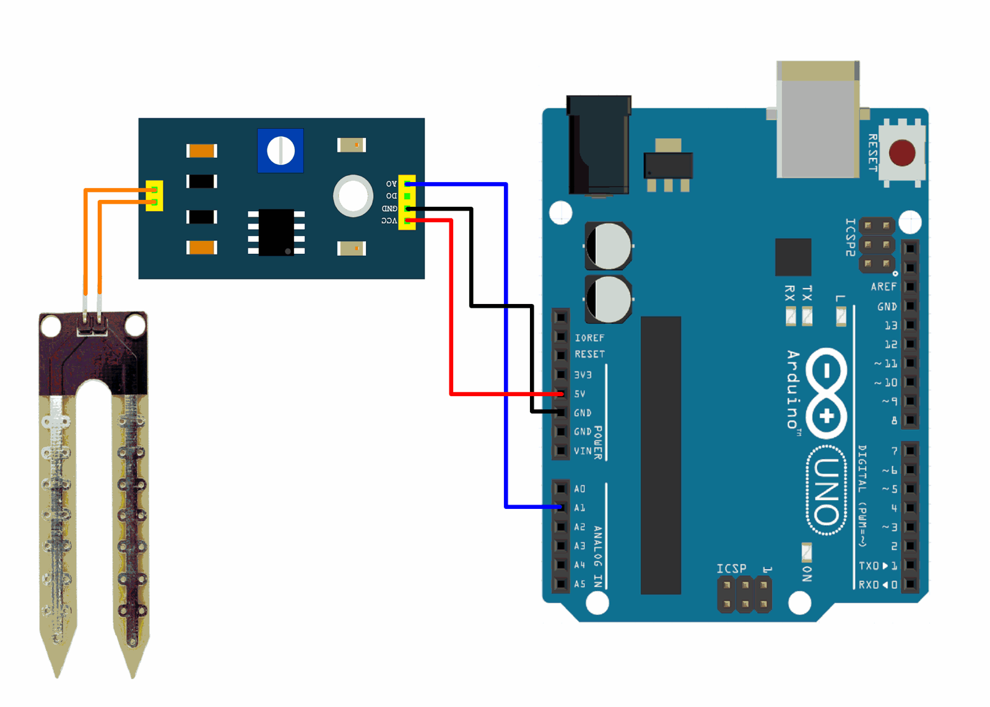

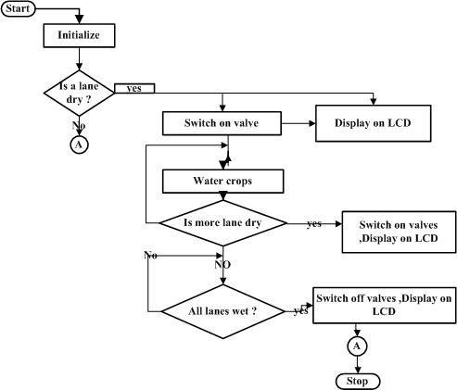

1. **Working Principle**

The working principle of a soil moisture measurement system depends on the type of sensor used, but the general process involves measuring the moisture content of the soil based on its physical properties. Here's a breakdown of the working principles for different types of soil moisture sensors commonly used in such systems:

**1. Capacitance Sensors:**

- Capacitance sensors work based on the principle that the dielectric constant of the soil changes with its moisture content.

- These sensors consist of two electrodes separated by a non-conductive material. When inserted into the soil, moisture in the soil acts as a dielectric material between the electrodes.

- By measuring the capacitance between the electrodes, capacitance sensors can determine the soil moisture content.

**2.Time Domain Reflectometry (TDR) Sensors:**

- TDR sensors measure soil moisture by sending electromagnetic pulses through the soil and analyzing the time it takes for the pulses to return.

- The speed of the electromagnetic waves traveling through the soil is influenced by the soil's dielectric constant, which varies with moisture content.

- By measuring the time delay between the transmitted and received pulses, TDR sensors can calculate the soil moisture content.

**3.Frequency Domain Reflectometry (FDR) Sensors:**

- FDR sensors operate similarly to TDR sensors but measure soil moisture based on the frequency response of the soil to electromagnetic signals.

- These sensors transmit high-frequency electromagnetic waves into the soil and analyze the reflected signals to determine soil moisture content.

- The dielectric properties of the soil affect the frequency response, allowing FDR sensors to estimate soil moisture levels.

**4.Resistance-Based Sensors:**

- Resistance-based sensors measure soil moisture by monitoring changes in electrical resistance as moisture levels change.

- These sensors typically consist of two conductive electrodes embedded in the soil. As the soil moisture increases, the conductivity between the electrodes changes.

- By measuring the electrical resistance between the electrodes, resistance-based sensors can infer the soil moisture content.

Regardless of the sensor type, soil moisture measurement systems typically involve the following steps:

- Calibrating the sensors to establish the relationship between sensor output and actual soil moisture content.

- Installing the sensors in the soil at appropriate depths and locations.

- Collecting data from the sensors using a data logger or monitoring system.

- Analyzing the data to determine soil moisture levels and trends over time.

By understanding the working principles of soil moisture sensors, stakeholders can effectively monitor and manage soil moisture levels for various applications, including agriculture, environmental science, water resource management, and engineering.

1. **Procedure**

The procedure for implementing a soil moisture measurement system involves several key steps to ensure accurate and reliable data collection. Firstly, objectives for the system are defined, specifying parameters to be measured and intended applications. Next, suitable sites for soil moisture monitoring are selected, considering factors like soil type, vegetation cover, and land use.

Once sites are chosen, appropriate soil moisture sensors are selected based on the objectives and environmental conditions. Sensors are installed according to manufacturer guidelines, ensuring proper placement and calibration for accurate measurements. Data loggers are set up to record soil moisture data at regular intervals, with power supplies installed to ensure continuous operation.

Data collection begins, with recorded data analyzed to identify trends and anomalies. Validation checks are conducted against reference standards or independent measurements to ensure data quality. Interpretation of soil moisture data helps inform management practices and decision-making processes.

Regular maintenance and calibration of sensors and data loggers are performed to maintain accuracy over time. Documentation of procedures and protocols ensures data integrity and reproducibility.

1. **Results and Discussion**

The results of soil moisture measurements provide valuable insights into the water content of the soil, which is crucial for numerous applications across various fields. These results offer a snapshot of soil moisture levels at specific locations and time intervals, aiding in decision-making processes and resource management strategies.

In agriculture, soil moisture measurements help farmers optimize irrigation schedules, ensuring that crops receive the appropriate amount of water for healthy growth while minimizing water waste. By monitoring soil moisture levels, farmers can adjust irrigation practices to prevent overwatering or underwatering, ultimately improving crop yields and resource efficiency. In environmental science, soil moisture data contributes to our understanding of ecosystems and their response to changes in water availability. Monitoring soil moisture levels in natural habitats helps researchers assess the health of ecosystems, predict drought impacts, and inform conservation efforts aimed at preserving biodiversity and ecosystem services. In water resource management, soil moisture measurements are essential for assessing groundwater recharge rates, predicting runoff and erosion, and managing water supply and demand. By monitoring soil moisture levels in watersheds and agricultural lands, water managers can make informed decisions about water allocation, drought preparedness, and sustainable water use practices.

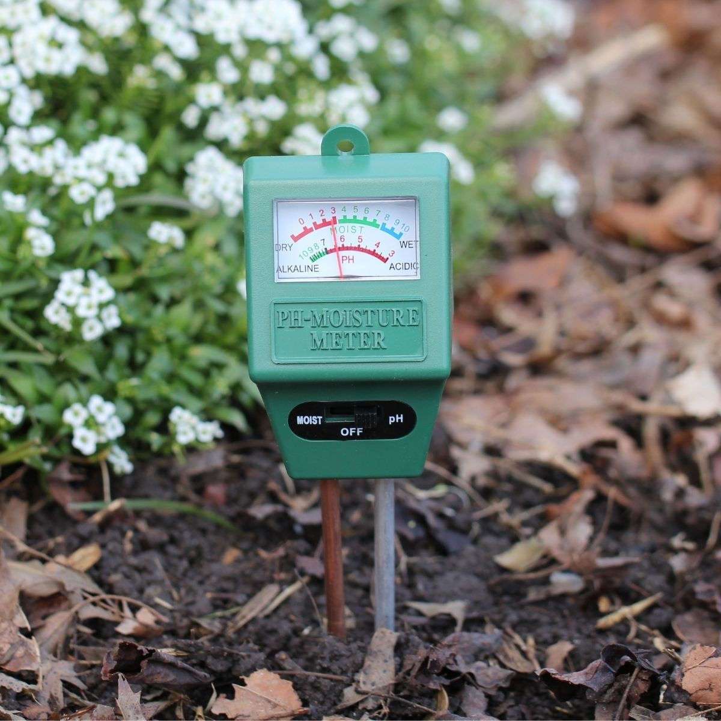

1. **Conclusions**

# In conclusion, soil moisture measurement systems play a vital role in various fields, offering valuable insights into soil-water dynamics and influencing decision-making processes. These systems provide accurate and reliable data on soil moisture levels, contributing to improved resource management, environmental conservation, and agricultural productivity. Through the deployment of soil moisture sensors, data loggers, and appropriate monitoring techniques, stakeholders can gain a deeper understanding of soil moisture variability across different landscapes and timeframes. This understanding enables optimized irrigation practices, enhanced ecosystem management, and more effective water resource allocation. The implementation of soil moisture measurement systems facilitates informed decision-making in agriculture, environmental science, water resource management, and engineering. By monitoring soil moisture levels, stakeholders can mitigate the impacts of drought, optimize water use efficiency, and support sustainable land management practices. Furthermore, soil moisture measurement systems contribute to scientific research efforts aimed at understanding the impacts of climate change, land use practices, and environmental disturbances on soil moisture dynamics. This knowledge is essential for developing resilient and adaptive strategies to address the challenges posed by changing environmental conditions.

# 

# Applications and Future Scope

# The applications of soil moisture measurement systems are diverse and span across various fields, while their future scope holds potential for further advancements and innovations. Here are some applications and potential future directions:

# **1.Agriculture:**

# - Optimizing irrigation practices to improve crop yields and water use efficiency.

# - Monitoring soil moisture to prevent overwatering or underwatering and reduce water wastage.

# - Integrating soil moisture data with precision agriculture techniques for site-specific management of crops.

# **2.Environmental Science:**

# - Studying soil-water dynamics to understand ecosystem health and resilience.

# - Monitoring soil moisture in natural habitats to assess biodiversity and habitat suitability.

# - Predicting and mitigating the impacts of drought on ecosystems and wildlife.

# **3.Water Resource Management**:

# - Assessing groundwater recharge rates and predicting water availability.

# - Monitoring soil moisture in watersheds to support sustainable water allocation and management practices.

# - Incorporating soil moisture data into hydrological models for improved water resource planning and decision-making.

# **4.Engineering and Construction:**

# - Evaluating soil moisture levels to assess soil stability and foundation integrity.

# - Monitoring soil moisture during construction projects to prevent structural damage and ensure safety.

# - Incorporating soil moisture data into geotechnical engineering designs for infrastructure projects.

# **5.Climate Studies and Weather Forecasting:**

# - Using soil moisture data to improve climate models and predictions of droughts and extreme weather events.

# - Studying the relationship between soil moisture and climate variability to better understand climate change impacts.

# - Integrating soil moisture measurements into weather forecasting models for more accurate precipitation forecasts.

# **Future Scope:**

# - Integration of soil moisture measurement systems with Internet of Things (IoT) technology for real-time monitoring and data analytics.

# - Development of advanced sensor technologies with improved accuracy, durability, and cost-effectiveness.

# - Expansion of soil moisture monitoring networks to cover larger geographic areas and provide more comprehensive data coverage.

# - Integration of soil moisture data with satellite imagery and remote sensing technologies for spatial analysis and mapping.

# - Exploration of machine learning and artificial intelligence techniques for automated analysis of soil moisture data and prediction of future trends.

# - Collaboration between researchers, policymakers, and industry stakeholders to address emerging challenges and opportunities in soil moisture monitoring and management.

# Overall, the applications and future scope of soil moisture measurement systems hold promise for addressing pressing environmental, agricultural, and water resource challenges while advancing scientific understanding and technological innovation.

# References

***1."Soil Moisture Measurement Techniques: An Overview" by S. R. Swain and A. K. Nayak.***

***2."Advances in Soil Moisture Sensing Technologies and Their Applications for Environmental Monitoring" by C. J. S. Pires, et al.***

***3."Soil Moisture Sensing: Technologies, Applications, and Challenges" by K. Manohar et al.***

***4."Remote Sensing of Soil Moisture: A Review" by W. Wagner et al.***

***5."Evaluation of Soil Moisture Sensors for Agriculture Applications" by A. Mahmood et al.***